Administrative Assistant

Application Pack

Grantham, Lincolnshire

Deadline: 15th October 2021
Welcome Letter

Dear Applicant,

Thank you for your interest in the position of Administrative Assistant. This application pack includes the following documents about Dosh and further information about the position of Administrative Assistant:
- About Dosh and the Dosh Promise
- Thera Group Structure and Vision
- The role in a nutshell: Administrative Assistant
- Job Description
- Person Specification
- Competencies
- Pay and Benefits

In addition, you can find further details about Dosh at www.dosh.org and about the Thera Group at www.thera.co.uk.
We value diversity in our team and promote equality and inclusion across Dosh. We welcome applications from people of all backgrounds who have a commitment to our values and are keen to learn, grow and contribute to our mission at Dosh.
If you have any questions regarding this application, or would like to contact me for an informal discussion, then please do so on
on 07841 052 174 or steve.raw@dosh.org.

Yours sincerely

Steve Raw
Managing Director, Dosh
About Dosh

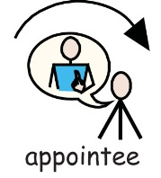  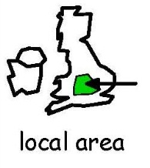 | Dosh is a not for profit company that supports people with a learning disability to have more control and more independence over their money.  Dosh is a specialist company within the Thera Group and provides support to people with a learning disability in England, Scotland and Wales. The company was set up in 2007.  People with a learning disability can receive support in a number of ways:  - Financial advocacy  - Person-centred appointeeship  - Account management for self-directed support  - Money checks  Dosh Financial Advocates are based locally so that people can receive support when they need it.  Dosh Financial Advocates are able to support people in many ways, including support to create a budget, open a bank account, apply for and manage benefits as well as provide support for families.  Our values are:
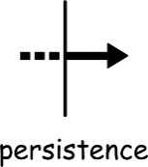

The Dosh Promise
We asked people we supported what was important to them and used what they said to write the Dosh Promise.
- I will be able to use my money to do the things I want.
- I can be as involved as I want in my money.
- I will spend my money in the way that I want.
- I will get the information I want about my money in a way I can understand.
- I will have my own financial advocate who visits me, knows what I like and listens to what I want.
- My financial advocate will give me support and information to help me manage my money.
- Dosh will tell me about my money, what they are doing and answer any questions I have.
- Dosh will help me to keep my money safe.

Group Structure
Dosh is an independent company within the Thera Group.
Thera’s group structure enables us to create local networks that meet the needs of the people we support and play an important role in the local communities. It also allows specialist companies like Dosh to meet particular needs and create bespoke services. 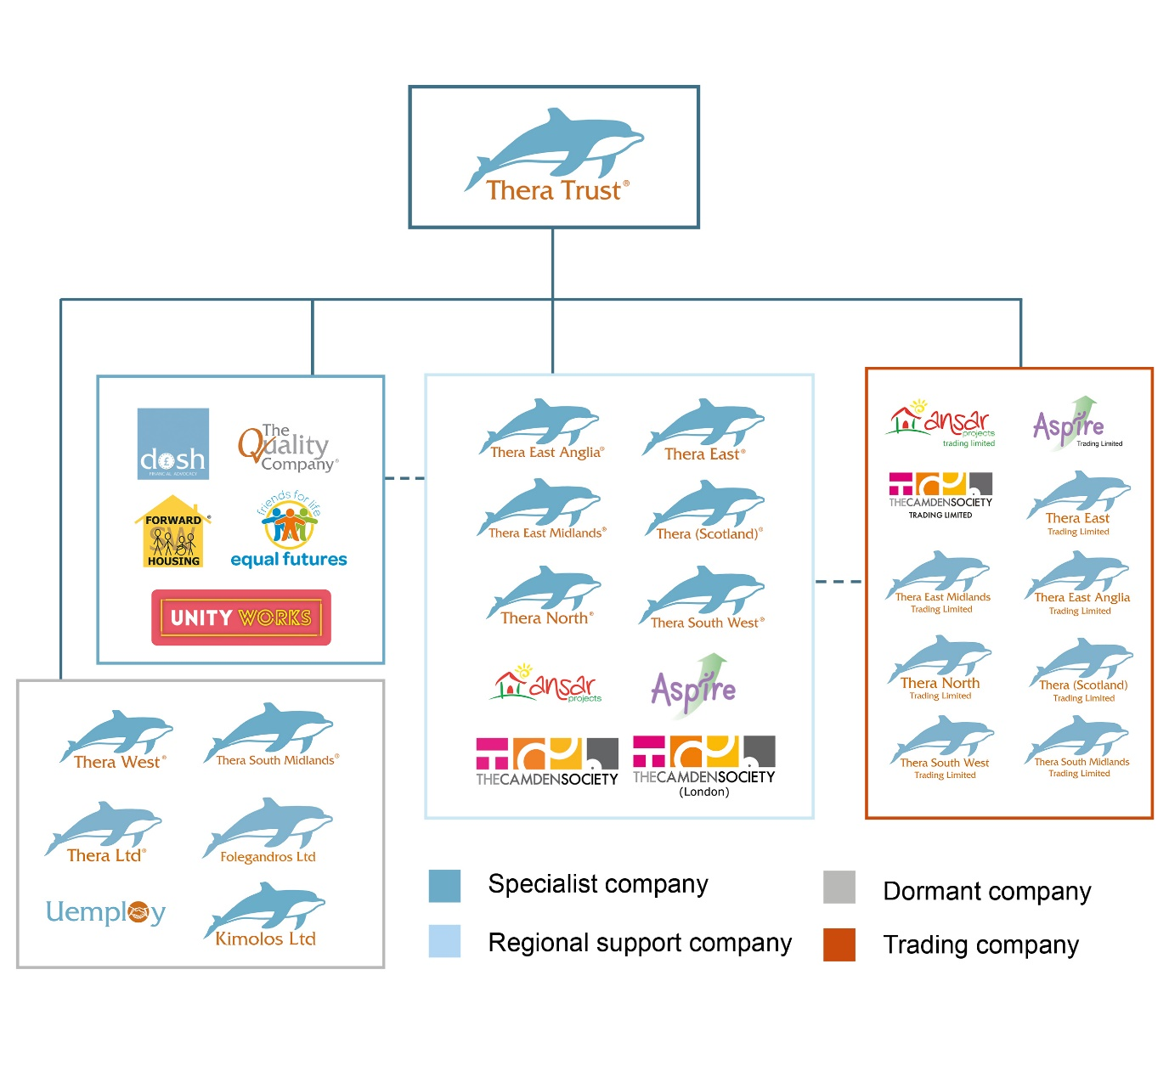Each Thera company is led by its own Board of Directors, with responsibility for the strategy and management of the company.
The Group is led by Thera Trust, a registered charity (1090163) which is based in Grantham, Lincolnshire.
Thera’s Vision
 | We will show that people with a learning disability can be leaders in society.
 | We will be controlled by people with a learning disability.
 | People supported by us can say how their Thera company is directed and managed.
 | People with a learning disability will design the support they want from us.
 | We will respect the rights and wishes of people at work, at home and in the community.
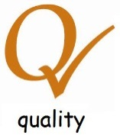 | People with a learning disability will check the quality of support from their Thera company.
 | Thera Group will be led by a charity.

The role in a nutshell: Administrative Assistant
Purpose: Efficient administrative support

Accountabilities:
- opening, scanning and otherwise processing all incoming and outgoing post to/from the Dosh office
- answering all emails and phone call queries that come to the Dosh office and forwarding on to the appropriate person or adding to Docuware.
- supporting Dosh advocates and the finance team to complete forms/paperwork and scan, email and/or post these where needed.
- supporting the new business team with new referrals by responding to enquiries, completing & posting applications to become appointee (BF56) and updating the New People database.
- supporting the finance team with storing Contract Variation Forms (CVFs) on Docuware and updating the CVF tracker, as well as undertaking requests to store other documents and all invoices.
- preparing information for and taking responsibility for the Docuware management system, including coaching and mentoring as required within the Dosh team.
- identifying and proposing improvements to existing systems, processes, and procedures.
- participating in organisational committees and meetings.
- providing administrative assistance to the rest of the Dosh team to be the central hub for Dosh support.
Job Description
Accountable to: Managing Director
Job Purpose
- To implement and manage the administrative processes of Dosh Financial Advocacy, including processing post and email documents, responding to telephone and email enquiries, scanning and filing and maintaining databases and records.
- To maintain accurate computerised records, databases and secure information systems for Dosh administrative purposes
- To support the appointeeship function of Dosh by completing and/or sending benefits forms, responding to queries and collating information and evidence to support the benefit claims of people supported by Dosh, under direction from the New Business Advocate, Financial Administrator, Financial Advocates and Leadership Team.
- To provide general support to other areas of Dosh services as required.

Person Specification
 | Essential | Desirable
Qualifications | - Evidence of commitment to ongoing personal and professional development  - Educated to GCSE level or equivalent in Maths and English  - Relevant clerical skills | - RSA II/Level 2 NVQ Business Administration/ Reception qualification or work experience which demonstrates competence  - NVQs or Diplomas in care or equivalent experience
Experience | - Experience in an administrative role | - Previous experience of providing administrative support in a busy office environment  - Experience working in:  - benefits,  - financial services,  - the care sector, or  - the non-profit sector  - Previous personal/family experience of disability, care giving and/or advocacy
Skills and Knowledge | - Computer literate  - Able to work independently and on own initiative  - Strong administrative skills in a confidential environment  - Excellent communication skills with people at all levels- written and verbal  - Organisational ability  - Methodical approach to work  - Able to deal with a variety of people with tact and diplomacy  - Good telephone manner  - Experience of Microsoft Office applications  - Good typing ability  - Working knowledge of spreadsheets  - Ability to deal with all matters in a confidential and discreet manner | - Skills and knowledge in:  - Welfare Benefits  - Banking  - Marketing and communication
Disposition | - Professional and personable  - Self-motivated  - Trustworthy  - Reliable  - Conscientious  - Work effectively under pressure  - Able to adapt to changing demands and work flexibly  - Team player  - Able to respond appropriately to a wide range of people  - Demonstrate commitment to support for people with a learning disability  - Personal values in keeping with Thera’s vision and Dosh’s values | - Confident  - Sense of humour
Personal Circumstances & Attributes | - Willing to undergo an enhanced Disclosure and Barring Service (DBS) check  - Good health evidenced by a good attendance record | - Professional appearance

Competencies
In relation to benefits support:
- Ensure the provision of accurate information to the Department for Work and Pensions (DWP) including the accurate completion of DWP forms and responding to telephone, email and online requests.
- Prepare responses to DWP enquiries including drafting letters for checking and approval; collating information requested either from records held or liaising with advocates to get additional information.
- Maintain a filing system for benefits letters & other correspondence.
- Maintain a general understanding of the work of Dosh, keeping abreast of developments in the learning disabilities and Financial Advocacy/Appointeeship arena including the basic benefits system and an understanding of the needs of the people supported and how best they can be met.

In relation to finance support:
- Scan, file and post Dosh managed account bank statements to all Dosh customers
- Scan and file invoices and record other payment requests as per Dosh’s payments process
- Maintain relevant databases as required to administer Dosh support.

General Administration:
- Prepare information for processing and maintenance of an accurate and up-to-date database of benefits, financial and other advocacy information for recording, storing, and retrieving data.
- Ensure that all computerised and manual records are input and maintained in a timely manner, are accurate, and stored in accordance with appropriate legislation.
- Administer the best interest decision (BID) process which includes coordinating the storage and clearing of BID applications
- Ensure that all post is logged, recorded, distributed and collated appropriately using Docuware and other tools on behalf of the Dosh team.
- Support and co-ordinate communication across Dosh in the case of service outages, challenges and collaborative work.
- Produce reports, letters, and other documentation as required, in relation to the services provided by Dosh.
- Ensure the provision of a quality administrative service to the Dosh Leadership Team and all Dosh colleagues as required
- Participate in the updating of material (e.g. Dosh forms and leaflets) as appropriate, and in conjunction with the Named Financial Advocates and Leadership Team
- Apply a good working knowledge of Dosh and Thera Group policies

IT & Systems
- Prepare information for and take responsibility for the Docuware management system, including coaching and mentoring as required within the Dosh team.
- Use other appropriate software to undertake job role, specifically the HR System and Microsoft Office
- Support the production of statistical reports using Dosh databases
- Identify and propose improvements to existing systems, processes, and procedures

General:
- Represent Dosh internally and externally, specifically with banks, DWP, support providers, family members, social services and other agencies.
- Liaise confidently with a wide range of people internally and externally
- Communicate effectively, orally and in writing, both internally and externally
- Participate in organisational committees and meetings
- Prioritise and manage your own time
- Work as part of a team and under own initiative
- Work effectively under pressure
- Apply knowledge and understanding of the issues faced by people with a learning disability

Other
- Have the ability to manage own professional development
- Understand the legal frameworks within which Thera and Dosh work
- Have a working knowledge of health and safety legislation and practice
- Have a good understanding or work towards a good understanding of the benefits system
- Protect operations by keeping personal and financial information confidential in line with current data protection regulations

Pay and Benefits

Hours of Work
- Full-time: 39 hours per week
- Full time preferred but part time applications also accepted for the right candidate, flexible working and job share options on discussion

Salary
- Grade 5 up to £18,119.14 per year pro rata

Pension
- Details available on request

Annual Leave
- 218.4 hours per year (including bank holidays) – equivalent to 5.6 weeks

Notice Period
- One month’s notice period on either side (subject to employer’s statutory increases).

Location
- Likely mainly based at Dosh’s Grantham office: The West House, Alpha Court, Swingbridge Road, Grantham, NG31 7XT
- Home working option in discussion with the administrative team
- Further travel may be required infrequently

Car Allowance & Expenses
- Home to Grantham office travel to be paid by the employee.
- Additional expenses paid as per Dosh policy

Additional Benefits
- Annual Pay Review
- Employee support line to support you and your family
- Continuous on the job training is provided
- Contributory Pension Plan
- Occupational Maternity Pay
- NVQ Funding
- DBS paid for by Dosh
We also offer an employee benefits scheme, which includes:
- Cycle to Work Scheme
- Health Cash Plan

We value diversity in our team and promote equality and inclusion across Dosh. We welcome applications from people of all backgrounds as we know that our diverse experiences, skills and interests make us stronger together.

We are a disability confident and equal opportunities employer. We encourage anyone who needs assistance with their application to contact the recruitment team on hrrecruitment@thera.co.uk.

How to Apply

All applications are processed centrally through the Thera Group, with shortlisting and interviews then undertaken by Dosh. To complete an application, please go to the Thera Group job application page: www.thera.co.uk/careers

Please ensure that your application includes specific examples, which clearly demonstrate your competencies and skills. Offers are subject to Disclosure and Barring Service (DBS) checks.

Deadline: 15th October 2021

Provisional interview dates: w/c 18th October 2021
(This will likely be an online meeting via Microsoft Teams or similar. We are happy to make accommodations and any adjustments needed to allow people with disabilities, IT or communication difficulties to participate in the interview. Please let us know what would help you.)

Start date: as soon as possible on completion of employment checks and on negotiation with the appointed candidate.
If you have any difficulty applying, please contact the Recruitment Team on 0300 303 1280 or email hrrecruitment@thera.co.uk .

